## Insights

During the analysis, some information was gained which was not in any initial question. Here, we will investigate them. In table below, number of transactions happened during and after campaigns held in each country is shown. We can see that id country is by far the most successful country for campaigns.

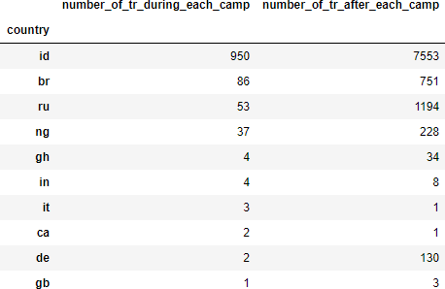

Most of the transactions are in this country, which can be seen in table below. So, the question here is that whether the number of campaigns held in this country was enough or not?

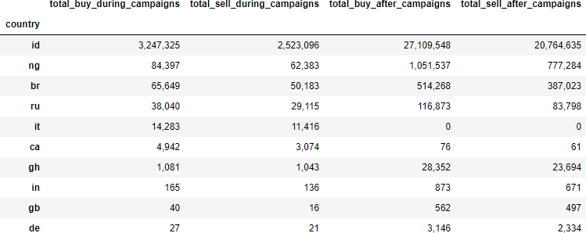

To answer this question, we need to find out which transactions did not happen during campaigns to see potential among customers. In table below, we see that while the

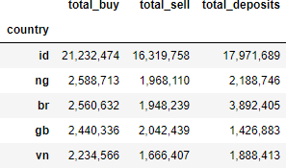

company have conducted 14 campaigns on this country, there are still a considerable amount of money that have been transferred on this site without any campaign involvement. To make it more clear, let’s compare total amount of money spent as total buy and total sell on this site in each country and compare it with numbers extracted above on a table. We have 4 columns for each country, showing how much money has been spent as total buy and total sell, and how much money was spent without any impact campaigns (means that they are organic customers came to visit site without any direct or indirect effect of campaigns). As we can see, the country “id” is by far the most popular region among our customers. It was something predictable. However, while 14 separate campaign was held in this region, there are still many customers who have visited the site without any campaigns. The difference between total_buy and total_buy_no_campaign is the amount of money earned by campaigns. The more this

distance is, the more successful campaigns are.

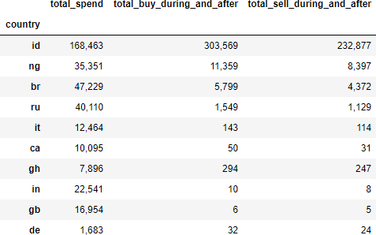

In diagrams above, there were some countries where campaigns were unsuccessful as they could not increase transactions enough to be profitable. However, there are some campaigns which they were a total fiasco, as they could not bring any customer at all. They are queried in table below.

